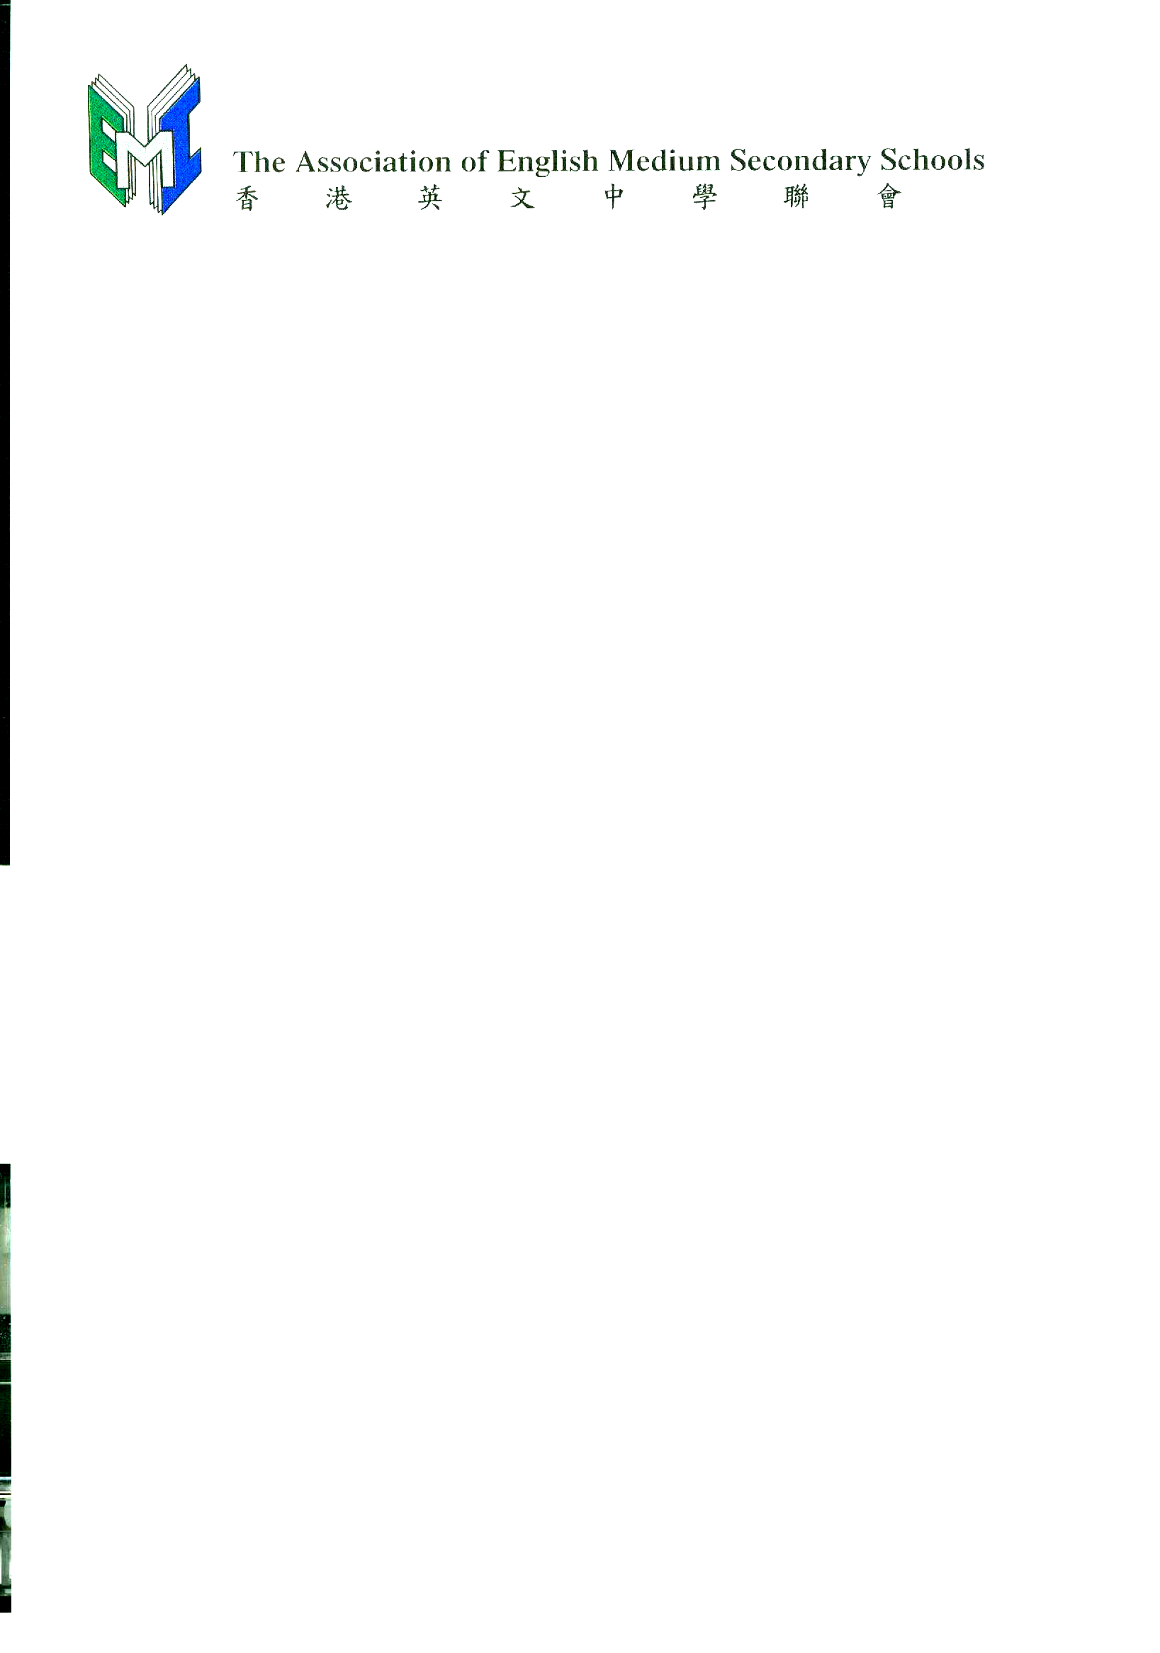
Annual General Meeting, 29 November 2005

Chairperson’s Report

1. Introduction:
The last school year, 2004-05, has been a busy year for all of us. In addition to our routine work, which, over the years, has increased significantly, we had to study and respond to the two consultation documents on “3+3+4” Reform and SSPA+MOI which will have a lasting impact on the Hong Kong education scene. The Executive Committee of the Association met many times to discuss these documents and we also met with EMB personnel, Working Group members and other interested parties to exchange views and ideas. In all this, we can honestly say that we have not let the interests of the Association blind us to the well-being of the education sector and of the community, especially the well-being of our staff, our students and their parents. Rather, we tried to demonstrate, in media interviews and newspaper articles, in our responses to the consultation documents, that the interests of the Association are inextricably intertwined with the interests of the education sector, and of society at large. What is good for our members is definitely good for Hong Kong youths, for their parents, for our staff and for the future of Hong Kong.

2. Meetings:
The Executive Committee met formally six times during the past year, on 20 October 2004, 27 November 2004, 16 December 2004, 1 March 2005, 6 April 2005, and 29 April 2005. In addition, there were several breakfast meetings to discuss matters requiring urgent attention. Representatives of the Executive Committee met with Mr Michael Tien and members of his Working Group on Review of Secondary School Places Allocation and Medium of Instruction for Secondary Schools a few times to exchange ideas. They also met with their counterparts of the Association of Hong Kong Chinese Middle Schools several times, in what proved to be a vain attempt to reach a consensus on the issue of medium of instruction in secondary schools.
The Association also held meetings to present to principals and teachers of our member schools and discuss with them the contents of the “3+3+4” Reform and the SSPA + MOI consultation document. Questionnaires to solicit their views and the views of parents were widely distributed and the responses were collated and analysed.

3. “3+3+4” Reform*:
Based on the views of member schools, the Association submitted its response to the consultation document “Reforming the Academic Structure for Senior Secondary Education and Higher Education --- Actions for Investing in the Future.” Now that EMB has published its report on “The New Academic Structure for Senior Secondary Education and Higher Education – Action Plan for Investing in the Future of Hong Kong,” we are pleased to note that except for the recommendations on the reduction of class size to 25 and on September 2010 as the implementation date of the reform, most of our recommendations had been considered and accepted by EMB.

4. SSPA + MOI*:
While schools and the community as a whole were broadly agreed on the general direction of the “3+3+4” Reform, this is certainly not the case with MOI, the medium of instruction in secondary schools.
In the “Review of Medium of Instruction for Secondary Schools and Secondary School Places Allocation – Consultation Document,” the Working Group chaired by Mr Michael Tien proposed that “continuing to uphold mother-tongue teaching should be the orientation of the MOI arrangement for secondary schools.” The Association, however, holds that, in view of the importance of English to Hong Kong and of the need to develop students’ potentials to the full, “students in all Hong Kong secondary schools should learn and be taught in a medium that is suited to their abilities and aspirations.” As a corollary, the Association urged the government to provide EMI school places to all EMI-capable students who desire an EMI education. We also urged EMB to eliminate the misallocation of non- EMI-capable students to EMI schools and, failing that, to provide EMI schools with extra resources for their education.
The Working Group will soon publish its final report. We hope against hope that the language issue that has plagued Hong Kong secondary education all these years will finally be laid to rest and look forward to the day when all Hong Kong students can receive an education through a medium that is suited to their abilities and aspirations.

5. Co-operation with Other Agencies:
The Association continues its co-operation with the Labour Department in the I.T. Seed Programme of the Youth Work Experience and Training Scheme and with the Lions Clubs International District 303 in the Lions International Youth Exchange 2005 Scholarship Environmental Essay Competition.
As for the Co-operation Programme on Workplace English Between HKGCC & AEMSS, the HKGCC has cancelled it and has instead launched a Pilot Business-School Partnership Programme 2005-06, in which each participating company adopts a school for a year and develops activities with the school to enhance students’ knowledge, language skills, etc. Eight members of the Association were invited by the HKGCC to take part. Should the pilot programme prove successful, it will be expanded to more companies and schools.

6. Vote of Thanks:
I would like to take this opportunity to thank all member schools, EMB and various organisations for their support and co-operation this year. Thanks are also due Mrs Anson Chan and Mr Kwan Ting Fai for kindly agreeing to be our Patron and Adviser respectively. Special thanks go to members of the Executive Committee who have given generously of their time and efforts to advance the causes and further the objectives of the Association.

I look forward to your continued support in the days ahead.

* To read the Association’s responses to the consultation documents in full, please go to
http://www.emi.edu.hk/eng-ver/rel_doc.html

