

By fax and by post

9 December 2011

Dear Principal/HOD (English) of EMI School,

2012 English Drama Fest

I am very pleased to invite your school to take part in the ‘2012 English Drama Fest’. This is our sixth year hosting this event that has proved to be immensely popular with EMI schools. Drama Fest is a stress-free activity that brings together students and teachers from different schools to share the fun and joy of English drama.

This year, we are very happy to offer a workshop to teachers that will help them learn more about the creative aspects of theatre. Our tutor, Mr. William Yip from Theatre Noir, will give a workshop at the studio of Theatre Noir on 14 January 2012. Please refer to the attached outline of the workshop and bio of Mr. William Yip. Schools participating in the 2012 English Drama Fest may send up to 2 teachers to attend the workshop, while schools not participating in it may send 1. Enrolment will be on a first-come-first-served basis, so please ask your teacher(s) to complete and fax the enrolment form as soon as possible.

2011 Drama Fest DVD and 2012 Drama Fest Fact Sheet

Schools that attended our Drama Fest briefing session on 7 October 2011 received a DVD of the 7 Outstanding Performances recorded at the finals at Tsuen Wan Town Hall. If your school wishes to have a copy of this DVD, please write to our Drama Fest Chairperson Ada Kwong at missadakwong@gmail.com or call 66852552.

As in previous years, we ask schools NOT to use elaborate sets and costumes and to limit their performance to not more than 15 minutes. If your school is entering this event for the first time, I urge your teachers to visit our website (www.emi.edu.hk) for details concerning the Drama Fest. All queries concerning the Drama Fest should be directed to Ada Kwong.

1

Venues and Prizes for 2012 Drama Fest

This year we are offering schools a choice of 5 venues over 3 days, from 27 April to 2 May 2012. We expect to have around 7 to 8 schools per session and each session will be from 9 am -12 noon or 2 - 5 pm with a live audience from the host school, participating schools and /or primary schools enrolled in SCOLAR’s drama-in-education programmes. Each session will be judged individually with 7 trophies to be awarded.

The prizes for each session are as follows:
Outstanding Performance
Outstanding Performers
Outstanding Teamwork
Outstanding Spoken English
Outstanding Script (original or adapted)
Outstanding Creativity

All participants, including backstage helpers, will receive a certificate issued by our Association.
Please make sure that you return the Entry Forms as soon as possible as places for the Drama Workshop and the Drama Fest are limited and allocation will be strictly on a first-come-first-served basis.

Drama Workshop Enrolment Form (Deadline: 22 December 2011)

Drama Fest Entry Form and Entry Fee ($800 per school) (Deadline: 10 January 2012)

First, fax the completed Drama Fest Entry Form and Drama Workshop Enrolment Form to:
Principal, Heep Yunn School
Fax No: 27153755

Then, write a cheque for $800 payable to the “Association of English Medium Secondary Schools” and send it by post, together with the Entry Form and Workshop Enrolment Form, to:
Principal
True Light Girls’ College
54A Waterloo Road
Kowloon

Lastly, I take this opportunity to wish you, your staff and students a very Merry Christmas and Happy New Year. I hope to see you at Drama Fest in April 2012 and at the prize presentation ceremony and outstanding performances in May 2012.

Yours sincerely,
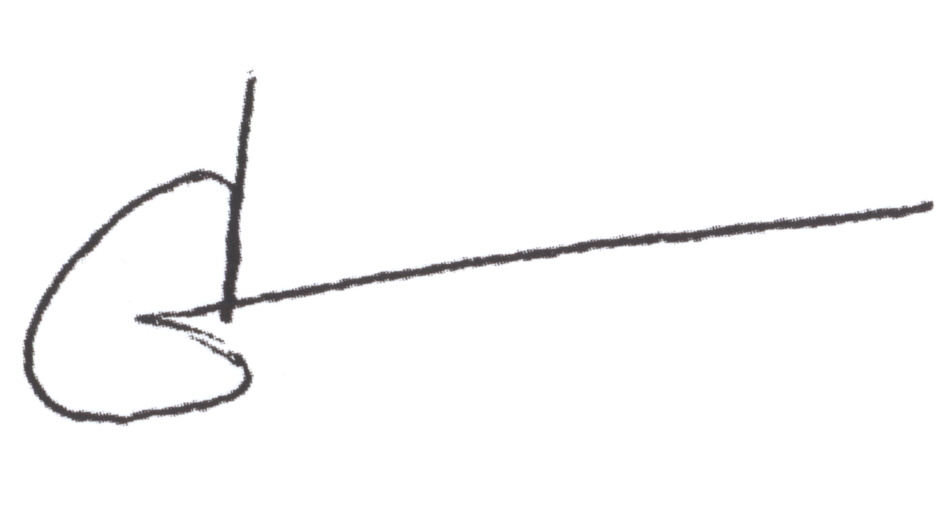

Carol Yang
Chairperson

2

