2012 English Drama Fest  Organised by the Association of English Medium Secondary Schools | 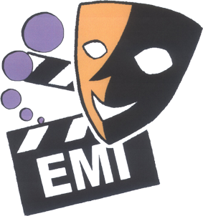

DRAMA WORKSHOP

Instructor: Mr. William Yip, Founder and Artistic Director of Theatre Noir

Date: 14 January 2012 (Sat)

Time: 2:00 – 4:30 pm (2 hrs. 30 mins)

Venue: Studio of Theatre Noir (3B Tontex Industrial Building, 2-4 Sheung

Hei Street, San Po Kong, Kowloon. – 10 mins’ walk from Diamond Hill MTR Station)

1-2 teachers from each school may apply. The course is free for 2 teachers if their school takes part in the 2012 Drama Fest and it is free for 1 teacher if his / her school does not take part. A brief bio of the drama instructor Mr William Yip and the outline of the course are attached.

Complete this form and fax it to the Principal of Heep Yunn School at 27153755 on or before 22 December 2011 to reserve places.

Teachers will not receive individual confirmation. They should check the name lists posted on the AEMSS website at www.emi.edu.hk in January 2012. In the event that a teacher cannot attend a workshop, he/she should find a replacement so that valuable resources are not wasted.

Name of Teacher(s)  . | Email address & mobile phone
1. ___________________________  2. ___________________________ | __________________________________  __________________________________

Name of School: _________________________________________________

Our school is *participating / not participating in the 2012 Drama Fest.
(*delete as appropriate)

Course Title: The Creative Aspects of Theatre

Course Content

The programme is an experiential workshop about “The Creative Aspects of Theatre”. Teachers will learn:

- How to activate the actors’ creative souls to be more confident and expressive?
- How to excite the playwrights’ creative minds to make dramatic stories?
- How to open the directors’ creative eyes to communicate effectively with the audience with visual elements?

Yes! The workshop is all about CREATIVITY. Let’s think outside of the box and have some fun!

Instructor: Mr. William Yip (see attached page)

All enquiries concerning the drama workshops should be directed to Ada Kwong at 66852552 or email missadakwong@gmail.com

.

