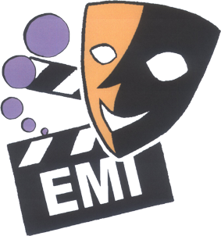

2011 English Drama Fest

Supporting organization & Advisors:
SCOLAR
The Hong Kong Academy for Performing Arts
Chung Ying Theatre Company
Hong Kong Art School

Organizer: The Association of English Medium Secondary Schools

FACT SHEET

WHY

- To promote the interest of students in English in a fun and active way
- To provide an opportunity for students at EMI schools to learn from each other in order to further enhance their English proficiency
- To prepare students for the New Senior Secondary Curriculum which places greater emphasis on language arts

WHEN and WHERE

8 October 2010 Briefing at True Light Girls’ College after AEMSS AGM

January 2011 Drama Workshops for teachers by drama experts
Details will be sent to schools in early December

7 - 15 April 2011 7 Drama Fest sessions each with 6-7 schools participating at
school halls, LCSD Civic Centre theatres or community
centres
May 2011 Prize Presentation and Outstanding Performances
(Venue to be confirmed later)

HOW

- Schools may choose to write their own original play or adapt one
- Duration of the play MUST NOT exceed fifteen minutes
- Schools need to bring their own furniture if the session is held at a Civic/Community Centre
- If the session is held in a school, the host school will provide basic furniture such as desks, chairs etc.
- Schools should provide their own simple props and costumes
- There is no limit to the number of actors/actresses
- Schools may use ONE pre-recorded CD for all sound effects
- No electronic preset lighting is allowed
- Use of the computer is NOT allowed

APPLICATION FOR ENTRY (Deadline: 7 January 2011)

- The entry fee is $500 per school. This includes free enrolment to the Drama Workshop in January 2011. Please complete the ENTRY FORM which will be faxed and mailed to schools in early December. You may also download the form from our website at www.emi.edu.hk. Make the cheque payable to ‘Association of English Medium Secondary Schools’.
- VERY IMPORTANT! Fax the completed Entry Form to 2568 9708 for priority allocation of date/venue and then send the Entry Form and Entry Fee of $500 to Mr. Tam Kim Hung, Principal of True Light Girls’ School, 54A Waterloo Road, Kowloon.

PRIZES

- All participants (actors and backstage helpers) will get certificates of participation.
- Trophies and certificates for the following categories will be awarded to each of the 7 Drama Fest sessions to be held in April 2011:

OUTSTANDING PERFORMANCE * (to perform in May 2011)
OUTSTANDING PERFORMER (2)
OUTSTANDING TEAMWORK
OUTSTANDING CREATIVITY (in the use of props and costumes)
OUTSTANDING SCRIPT (original or adapted)
OUTSTANDING SPOKEN ENGLISH

For more details about the 2011 English Drama Fest, please visit our website www.emi.edu.hk or contact Liliana Kung at liliana@netvigator.com / 9888 3150.

