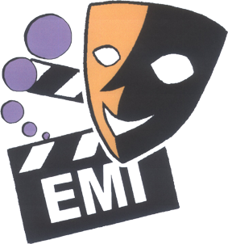

2010 English Drama Fest

Consultants: NET Section, Education Bureau
Chung Ying Theatre Company
HK Academy for Performing Arts
Organizer: The Association of English Medium Secondary Schools
Sponsor: SCOLAR

FACT SHEET

WHY

- To promote the interest of students in English in a fun and active way
- To provide an opportunity for students at EMI schools to learn from each other in order to further enhance their English proficiency
- To prepare students for the New Senior Secondary Curriculum which places greater emphasis on language arts

WHEN and WHERE

25 September 2009 Briefing at True Light Girls’ College after AEMSS AGM

January 2010 Drama Workshops for teachers by drama experts
Details will be sent to schools in early December
- Stage management and production
- Choreography for Beginners

19-23 April 2010 7 Drama Fest sessions each with 6-7 schools participating
Venue: school halls or LCSD civic centres

15 May 2010 Prize Presentation and Outstanding Performances
HOW

- Schools may choose to write their own original play or adapt one
- Duration of the play must NOT exceed fifteen minutes
- Schools need to bring their own furniture if the session is held at a civic centre
- If the session is held in a school, the host school will provide basic furniture such as desks, chairs etc.
- Schools should provide their own simple props and costumes
- There is no limit to the number of actors/actresses
- Schools may use ONE pre-recorded CD for all sound effects
- No electronic preset lighting is allowed
- No use of the computer is allowed

APPLICATION FOR ENTRY (Deadline: 8 January 2010)

- The entry fee is $400 per school. Please complete the ENTRY FORM which will be faxed to schools in early December. You may also download the form from our website at www.emi.edu.hk. Make the cheque payable to ‘Association of English Medium Secondary Schools’.
- IMPORTANT! Fax the completed Entry Form to 2568 9708 for priority allocation of venue/date and send the Entry Form and Entry Fee to Mr. Tam Kim Hung, Principal of True Light Girls’ School, 54A Waterloo Road, Kowloon

PRIZES

- All participants (actors and backstage helpers) will get certificates of participation.
- Trophies and certificates for the following categories will be awarded to each of the 7 Drama Fest sessions to be held in April 2010:
OUTSTANDING PERFORMANCE * (to perform on 15 May 2010)
OUTSTANDING PERFORMER (2)
OUTSTANDING TEAMWORK
OUTSTANDING CREATIVITY (in the use of props and costumes)
OUTSTANDING SCRIPT (original or adapted)
OUTSTANDING SPOKEN ENGLISH

For more details about the 2010 English Drama Fest, please visit our website www.emi.edu.hk or contact Liliana Kung at liliana@netvigator.com / 9888 3150.
All queries will be answered!

