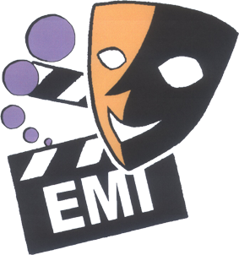

2009 English Drama Fest

Consultants: NET Section, Education Bureau
Chung Ying Theatre Company
Organizer: The Association of English Medium Secondary Schools
Sponsor: SCOLAR

FACT SHEET

WHY

- To promote the interest of students in English in a fun and active way
- To provide an opportunity for students at EMI schools to learn from each other in order to further enhance their English proficiency
- To prepare students for the New Senior Secondary Curriculum which places greater emphasis on language arts

WHEN and WHERE

30 September 2008 Briefing at True Light Girls’ College

January 2009 Drama Workshops for teachers by drama experts from
Hong Kong Art School and sponsored by SCOLAR

April 2009 7 Drama Fest sessions at 6 different venues

16 May 2009 Performance Day (venue to be confirmed)

HOW

- Schools may choose to write their own original play or adapt one
- Duration of the play must NOT exceed fifteen minutes
- Schools need to bring their own furniture if the session is held at a civic centre
- If the session is held in a school, the host school will provide basic furniture such as desks, chairs etc.
- Schools should provide their own simple props and costumes
- There is no limit to the number of actors/actresses
- Schools may use ONE pre-recorded CD for all sound effects
- No electronic preset lighting is allowed

APPLICATION FOR ENTRY (Deadline: 9 January 2009)

- The entry fee is $400 per school. Please complete the ENTRY FORM (which you may download from our website at www.emi.edu.hk) and make the cheque payable to ‘Association of English Medium Secondary Schools’
- Fax the completed Entry Form to 2568 9708 for priority allocation of venue/date and send the form and entry fee to Mr. Tam Kim Hung,
Principal of True Light Girls’ School, 54A Waterloo Road, Kowloon

PRIZES

- All participants will get certificates of participation.
- Trophies and certificates for the following categories will be awarded to each session of 6-7 schools:
OUTSTANDING PERFORMANCE
OUTSTANDING PERFORMER (2)
OUTSTANDING TEAMWORK
OUTSTANDING PROPS & COSTUMES
OUTSTANDING SCRIPT (original or adapted)
OUTSTANDING SPOKEN ENGLISH

For more details about the 2009 English Drama Fest, please visit our website www.emi.edu.hk or contact Liliana Kung at liliana@netvigator.com.
All queries will be answered!

