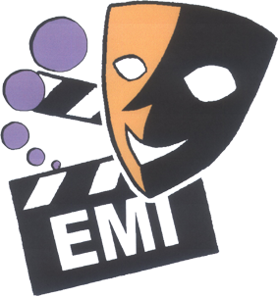

2009 DRAMA FEST
Organised by the Association of English Medium Secondary Schools

Supporting Organisation: SCOLAR

Advisors: NET Section, EDB
Chung Ying Theatre Company
Hong Kong Academy for Performing Arts
Hong Kong Art School

Adjudicators for the 7 Sessions

22 April  Session 1  2:00-5:00 pm  True Light Girls’ College | 23 April  Session 2  2:00-4:30 pm  St Stephen’s Girls College | 24 April  Session 3  2:00-5:00 pm  Shau Kei Wan Govt. Sec School | 27 April  Session 4  2:30-5:00 pm  Ngau Chi Wan Civic Centre | 28 April  Session 5  2:00-5:00 pm  Kiangsu-Chekiang College (Shatin) | 29 April  Session 6  2:30-5:00 pm  Ngau Chi Wan Civic  Centre | 29 April  Session 7  2:00-4:30 pm  Tsuen Wan Govt. Secondary School
Ms Dora To  Hong Kong  Art School | Mr Irving Koo  Chairman HKEAA | Mr Irving Koo  Chairman HKEAA | Dr Peter Jordan  HKAPA | Mr Ko Tin Lung  Chung Ying Theatre Company | Mr Irving Koo  Chairman HKEAA | Mr. Simon Tham  NET Section  EDB
Mr. Stewart Carry  Queen’s College | Dr Maureen Coulter  YMCA of HK Christian College | Ms Julien Hawthorne  St Stephen’s Girls’ College | Mr. Jocelyn Gagnon  YMCA of HK Christian College | Ms. Christine Bennet  Queen’s College | Ms Phoebe Chan  Hong Kong  Art School | Ms. Tanya  Kempston  NET Section  EDB
Miss Helen Li  Heep Yunn School | Ms Kristina Janavicius  Shau Kei Wan Govt Sec School | Miss Venus Yeung  Heep Yunn School | Miss Phoebe Lee  St Mark’s School | Mr Robert Haines  St Stephen’s College | Miss June Ho  Munsang College | Mr. David Johncock  Marymount Secondary School

ABOUT OUR ADJUDICATORS

Ms Dora To (Hong Kong Art School)

Miss To is an English Drama teacher at Our Lady of the Rosary College. She strongly believes in the unique benefit and value of Drama in bringing the elements of life back to English teaching and learning. She has been working on a school-based English Drama curriculum program for both junior forms and New Senior Secondary students at school.

She is currently assisting SCOLAR and the Hong Kong Art School to design Learning English through Drama Workshops for Primary School English teachers as part of the ‘Drama-Education’ English Alliance Project.

She has a BA in English Language and Literature from the Chinese University of Hong Kong and a MEd in Drama Education from Griffith University (Brisbane).

Mr. Stewart Carry (Queen’s College)
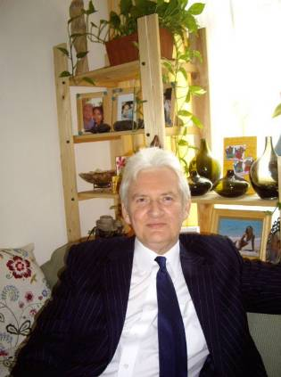
A native of Dublin and graduate of University College Cork, Stewart has spent most of his teaching career overseas, from Zambia to Botswana and then a brief stint in South Africa before independence in 1994. From there he returned to the UK where he took up a fresh challenge as a Social Worker and Special Needs teacher in London. A few years later, he accepted a post in Singapore before joining the staff of Queen’s College in 2000.

He has always had a keen interest in Drama and the Arts, and has welcomed the opportunity to become involved in school productions wherever he has been. Among his wider interests, Stewart enjoys traveling, reading and playing music. He is an avid hoarder of music DVDs and is quite possessive of his collection!

Miss Helen Li (Heep Yunn School)
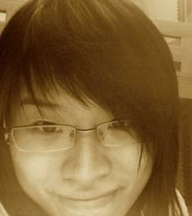
Miss Li is an English Language and Literature teacher at Heep Yunn School. She has been actively involved in drama productions with students for more than four years and has worked on several school-based materials related to language arts, such as poems & songs, novels, short stories, films and drama. She studied English Literature and Translation at the University of Hong Kong where she gained the Bachelor of Arts and she studied English Language and Music Teaching at the Chinese University of Hong Kong where she gained the Post-graduate Diploma of Education. She worked as a piano teacher and involved in various piano competitions, as well as participating in various drama productions when she was a student which enriched her experience in performing arts. Also, the experience of working as a student intern in the Education Bureau allows her to have a broader horizon in the education field.

She believes that teaching literature is sharing the great aesthetic pleasure in language with students whereas promoting performing arts inspires students’ confidence and awakens their potentials, which is one of the keys of opening the door towards personal growth.

Mr. Irving Koo (Chairman, HKEAA)

Mr. Koo currently is Chairman of the Hong Kong Examinations and Assessment Authority and Chairman of the Board of Directors of the newly formed Hong Kong Academy for Gifted Education. He is also a member of the Education Commission. Formerly he has been Chairman of the Steering Committee of the Quality Education Fund. Other than education, Mr. Koo is also interested in the Arts and both Council Chairman of the Art School of the Hong Kong Arts Centre and a member of the Performing Arts Committee.

A business manager by profession, Mr. Koo has previously held senior positions at the Jardine Matheson Group and CLP Holdings.

Mr. Koo is a graduate of the Chinese University of Hong Kong with a BA (Language and Literature) and has an MBA degree.

Dr. Maureen Coulter (YMCA of Hong Kong Christian College)
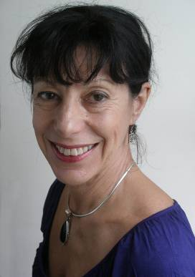
Maureen Coulter is a former dancer, professional dance teacher, and a qualified secondary school teacher. She studied Drama, English Literature and French Literature at the University of Canterbury, New Zealand where she gained her MA in Renaissance Drama and her PhD in Literature and Dance Aesthetics.

Dr Coulter taught English Literature for seven years at the University of Canterbury and for two years was Head of Senior Drama at a New Zealand secondary school. She taught Dance History and Dance Aesthetics for one year at The Hong Kong Academy for Performing Arts, and has been teaching for four years at YMCA of Hong Kong Christian College where she is Teacher in Charge of both English Literature and Theatre Arts.
Dr Coulter has many years’ experience as a performer, choreographer, designer and director of student drama.

Ms. Kristina Alexandra Janavicius (Shau Kei Wan Government Secondary School)

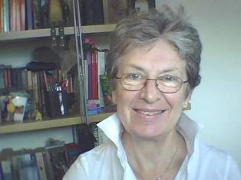
Ms Janavicius has been the NET teacher at Shau Kei Wan Government Secondary School since 2000. She worked as an English or EFL/ESL teacher in Australia, England and Greece before coming to Hong Kong. She believes that drama has a vital role to play in the learning of English in Hong Kong as a way of making it a living language used for self expression.

She has a BA and MA in Linguistics from Sydney University. She also has the RSA Diploma in Teaching English as Foreign Language.

Ms Julien Hawthorne (St. Stephen’s Girls’ College)
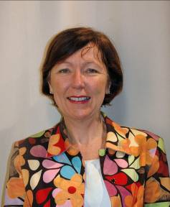
Ms Hawthorne is an English and ESL teacher, who has a passion for drama and theatre, which has taken her from performing in school plays to directing them, with some amateur dramatics along the way. She came to Hong Kong on the NET scheme, having taught for almost twenty years in a variety of secondary schools and university programs in Australia.

Miss Venus Yeung (Heep Yunn School)
Miss Yeung is an English and Literature teacher in Heep Yunn School. Before that she taught in Shatin for three years and has been engaging in drama productions with students since then. Miss Yeung studied in the University of Hong Kong, the Chinese University of Hong Kong and Macquarie University, Sydney with a degree in English Studies and Chinese Language and Literature. She worked in the Hong Kong University Press and took part in internships with the CCTV, Beijing and Asia Weekly Magazine when she was a student. Miss Yeung believes literature and performing arts are enlightening and enriching. She is going to continue her adventure in the cultural arena with her students

Dr. Peter Jordan (The Hong Kong Academy for Performing Arts)

Dr. Jordan is a theatre director and actor. He is now Head of Acting of the School of Drama, Hong Kong Academy for Performing Arts,

Mr. Jocelyn Gagnon (YMCA of Hong Kong Christian College)

Mr. Gagnon has been performing on stage as an actor, singer and musician for more than 30 years. Since he came to Hong Kong, he has been involved in musicals and children theatre as a member of the Hong Kong Singers and is also a committee member of this organization and the Purple Theatre Group. In Canada, he was involved in productions of musicals with both teenage and adult groups.

Miss Phoebe Lee (St. Mark’s School)

Miss Phoebe Lee has a Master’s degree from Central School of Speech and Drama in Theatre Directing and a MPhil degree from University in Hong Kong with the focus on drama and English Literature. Prior to teaching, she has taken various theatre roles in the industry. She has directed Beyond the Horizons and Miss Julie.

She is now an English Drama Teacher in St. Mark’s School. Her main duties are to develop the drama classes for the junior forms and to lead the drama group.

Mr. Ko Tin Lung (Chung Ying Theatre Company)

Appointed as Artistic Director of the Chung Ying Theatre since 1993, Mr. Ko has written and directed a number of outstanding productions, recent works include Tuesdays with Morrie and For You are with Me. Mr. Ko has received numerous awards, including the Stage Director of the Year Award from the Hong Kong Artists Guild in 1991, the Ten Years Outstanding Achievement Award from the Hong Kong Federation of Drama Societies in 1994 and Best Director for his directorial work in The School and I in the 4th Hong Kong Drama Awards. In 2006, he received awards in the Secretary for Home Affairs’ Commendation Scheme in recognition of his outstanding contribution to Hong Kong arts and cultural development.

Mr. Ko is currently the chairman of Arts Promotion Committee, chairman of Drama Group & member of strategy committee of Hong Kong Arts Development Council, an advisory board member of the Leisure and Cultural Services Department, School of Drama of The Hong Kong Academy for Performing Arts and the Radio Television Hong Kong, as well as executive committee member of the Hong Kong Federation of Drama Societies and Chairman of Arts.

Ms. Christine Bennett (Queen’s College)

Ms Bennet has been teaching at Queen’s College since coming to Hong Kong in 2006. Previous to that she taught in Brunei for two and a half years. A native of New Zealand, Ms Bennet taught mainstream English for many years in her home country. This included teaching drama to junior forms and feels that the opportunities the subject provides for self expression and creativity for all students, including the less academic, is invaluable

Robert Haines (St. Stephen’s College)

Mr. Haines was a History and Drama teacher in Canada for 5 years before moving to Hong Kong in July 2007 to teach at St. Stephen’s College (Stanley). Prior to teaching, he appeared on the stage, TV, and film in Canada after graduating from Ryerson Theatre School in Toronto, Canada.

Ms Phoebe Chan (Hong Kong Art School)

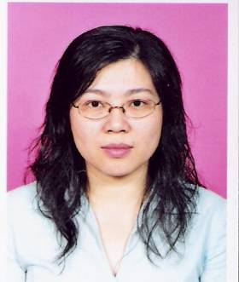
Phoebe Chan is Lecturer/Programme Coordinator (Drama Education) at the Hong Kong Arts School, where she convenes a Master of Drama Education Programme in collaboration with Griffith University (Australia), and assumes the position of Head Adjudicator with the Hong Kong School Drama Festival. She obtained her Master’s Degree in Drama in Education at the University of Central England, and is currently undertaking her PhD study with Griffith University. For more than ten years, she has worked extensively with various theatre companies, schools, governmental and community organisations in stage performance, drama education, research, publication and trainers' training.

Phoebe has devised, performed in, and directed a wide genre of plays including Applied Theatre, Theatre-in-Education works, experimental theatre and musicals. With Theatre du Pif's Fish Heads and Tales, she had toured to the Edinburgh Fringe Festival and various community venues throughout Scotland; the play also held subsequent tours to Beijing and Macau

Miss June Ho (Munsang College)


Being the Careers Mistress, English and Bible teacher of her serving school, Miss Ho is always on the lookout for stretching her students’ sky in whole-person development through diversified learning and exposure. She is currently involved in school OLE plans for the NSS curriculum.

Her passion for literature, music and drama has been perpetually augmenting ever since from an assignment of cross-casting as Ronnie in The Winslow Boy in her second year junior high and a repertoire of children musical productions when she was a university student in the States. She sang and directed children’s musicals in churches there and also involved in the university theatre production of children’s musical “Alice in Wonderland”.

Mingling her service to the Lord and her interest, Miss Ho directed the Children’s Choir of Kowloon International Baptist Church for seven years after returning to Hong Kong whilst she conducted Christmas programs of children’s musicals such as A stable fit for a King, Jesus in Egypt and Not a creature was stirring etc. She also directs the Christian Choir of Munsang College to sing in various school functions for over ten years and Christmas caroling programs in hotels for the last two years.

Miss Ho was a graduate of BBA (Marketing) and Music (OBU) in the States, PGDE in English (HKBU), MA in Language Studies (HKBU) and Diploma in Careers Guidance & Counseling (CUHK).
Mr. Simon Tham (NET Section, EDB)
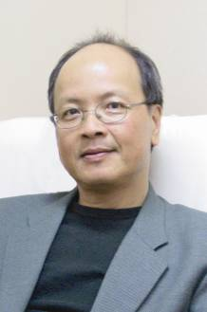
Mr. Tham has more than 30 years of extensive experience in English language and literature teaching, teacher training, curriculum development, inspection and is now Head of the NET Section in the Hong Kong Education Bureau. He has a great interest in and love for language arts, especially poetry, drama and speech.

Ms Tanya Kempston (NET Section, EDB)
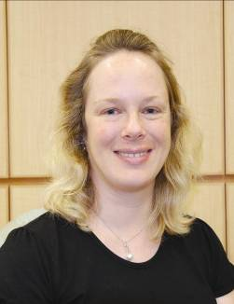
After graduating with a degree in English Language and Literature from the Queen's University of Belfast in the UK, Miss Kempston took a PGCE in English and Drama at the same institution. She taught in Belfast and Osaka City, Japan before moving to Hong Kong in 2001, where she was a NET and Head of English Literature at Belilios Public School from 2001-2005.

She was awarded a Master’s Degree with Distinction in Drama and Theatre Education by the University of Warwick in the UK in 2006 and now works for the Hong Kong Education Bureau NET Section as a Curriculum Officer and Advisory Teacher.

Mr. David Johncock (Marymount Secondary School)

David Johncock's first experience of drama was when he was seven years old. He wrote a story about an elephant which his teachers were so impressed with that they decided to turn it into a play - but he still only got to play the elephant's back end! David has been teaching in Hong Kong for 13 years. He is the NET at Marymount Secondary School, where he teaches English Language and Literature in English as well as being responsible for drama. David has directed many plays for Marymount including My Fair Lady, The Importance of Being Earnest, Macbeth, A Midsummer Night's Dream, Twelfth Night, Orpheus, Much Ado About Nothing and Hamlet.

This year he is directing The King and I for a production that will be staged at Marymount in July.

