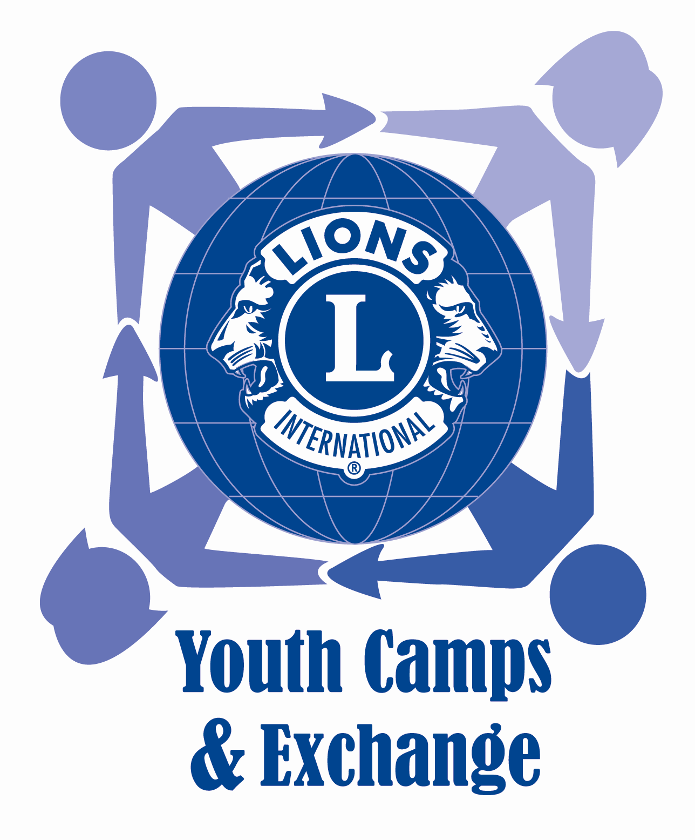  Lions Youth Camp &  Exchange Committee  Chairperson  Lion Salina Lo  Advisors  Lion Tam Wing Kun, JP  Lion Teresa Mann  Lion Paul Fan, JP  Lion Douglas Chan  Lion Judy Sin  Lion Joseph Ng  Lion Christina Ko  Lion Duffy Wong, JP  Lion Rosana Ip  Lion Pappy Au  Mr. Ho Lai Kit  Mr. James Lam  Miss Mabel Mak  Co-Chairpersons  Lion Salina Lo  Ms Carol Yang  Ms. Joyce Chan  Ex-officio  Lion Kenneth Ng  Vice Chairpersons  Lion Samuel Yeung  Lion Henry Law  Lion Gary Luk  Lion Eddie Lam  Lion John Wong  Lion Lana Yuen  Honorary Secretary  Lion Eva Lau  Honorary Treasurer  Lion Sammy Shum | 18th LIONS INTERNATIONAL YOUTH EXCHANGE SCHOLARSHIP  ESSAY COMPETITION ORGANIZING COMMITTEE  c/o Lions College, 90 Hing Shing Road, Kwai Fong, Kwai Chung, New Territories, Hong Kong.  Tel: 26147938 Email: yec.essay2018@gmail.com Website: http://www.yecamp.com/  16 October 2017  School Principals,  English Panel Chairpersons, and  Teachers-in-charge of  the Student Environmental Protection Ambassador Scheme,  and the Hong Kong Award for Young People,  All Secondary Schools of Hong Kong SAR and Macao SAR  Dear Sirs/Madams,  18th Lions International Youth Exchange Scholarship  Theme of Essay Competition: Smart City and the Environment  Since 1961, the Lions Clubs International has proudly provided hundreds of outbound exchange places for the young people each summer. These young people have joined international exchange camps and host families in about 100 cities around the world, with the aim of fostering the spirit of global citizenship. We are now pleased to announce that in summer 2018, we will once again sponsor qualified young people to represent Hong Kong and Macao in this meaningful activity. Selection will be made by means of an English essay competition: the top ten winners from Hong Kong, Macao and China will receive full scholarships to participate in International Exchange Camps.  May we cordially invite you to disseminate information about this competition to students at Secondary 4, 5 and 6, and to encourage them to participate? To qualify for the outbound exchange camp, students need to be between 16 and 20 years old on 30 June, 2018. The essay should be no more than 1200 words in length. Shortlisted participants will be invited to attend a personal interview in Hong Kong SAR, after which the ten finalists, together with other participants from the Mainland China, will present their works by PowerPoint in public to a panel of judges at a venue in Hong Kong.  By participating in this competition, students will have not only the chance to win a full international exchange scholarship, but also the opportunity to broaden and deepen their awareness of contemporary issues affecting the future of humanity, the environment and the economy. The essay topic itself has been carefully chosen to broaden global and educational horizons and to improve skills in English, research methods, and analytical thinking. For members of AYP, participation in the Lions overseas exchange programme can also help them to fulfil the requirement in the Gold Level Residential Project Section.  We are pleased to enclose herewith a poster, a fact sheet, and a registration form for information and distribution to your students. Essays, in MS Word format, together with the completed registration form, should be submitted by completing a google-form to yec.essay2018@gmail.com. Submissions should be emailed no later than 11:59 pm on Friday, 5th January 2018. More information is available at http://www.yecamp.com. We very much look forward to a response from you and your students.  Yours faithfully,  Lion Salina Lo Carol Yang Joyce Chan  Co-Chairpersons  18th Lions International Youth Camp Scholarship  Essay Competition Organizing Committee

