 | The Association of English Medium Secondary Schools  香港英文中學聯會
c/o St. Stephen’s College, 22 Tung Tau Wan Road, Stnley

9th September 2016
Dear Principal,
Warmest greetings from the Association of English Medium Secondary Schools (AEMSS)! The new academic year 2016-17 marks another new cycle of the MOI issue. The executive committee of AEMSS would like to express our heartfelt thanks to your cooperation and support in the past years on providing the opportunities to uphold teaching in the medium of English for our next generations. We hope you and all your colleagues have a rewarding and prosperous new school year.

The AEMSS was established in November 2000. Our aims are to promote English as the medium of instruction in schools, to plan for the future development of English medium schools in collaboration with the Government, enhance the image of English medium schools, seek parity treatment with other public sector schools, and canvass support from parents and community.

May I take this opportunity to thank you all for your support again in the past years, and we sincerely invite your school to join our Association as Full member or Associate member. Please refer to the attached membership renewal form for details of the membership, and return it by fax to Mr. TAM Kim Hung, Principal of True Light Girls’ College (fax number 2782 5300).

The Annual General Meeting of 2016 has been scheduled in the afternoon on 1st November 2016 (Tuesday). This year we are honoured to have Mr. Huang Lester Garson JP, Chairman of the Standing Committee of Language Education and Research, to join us as our officiating Guest of Honour and share with us his view on language education in Hong Kong. At this year’s AGM, we also need to elect new office bearers of the executive committee for the year 2016-2018. Please find attached the nomination form and send it back to Principal Tam Kim Hung of True Light Girls’ College on or before 14 October 2016 (Friday).
We look forward to meeting you at the AGM and in our coming activities.

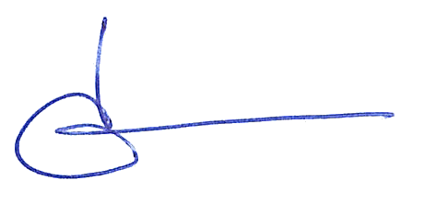
Yours sincerely,
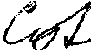

_____________________ ____________________
Lee Chun Hung Dave Yang Ching Carol
Chairperson Vice Chairperson
AEMSS AEMSS

