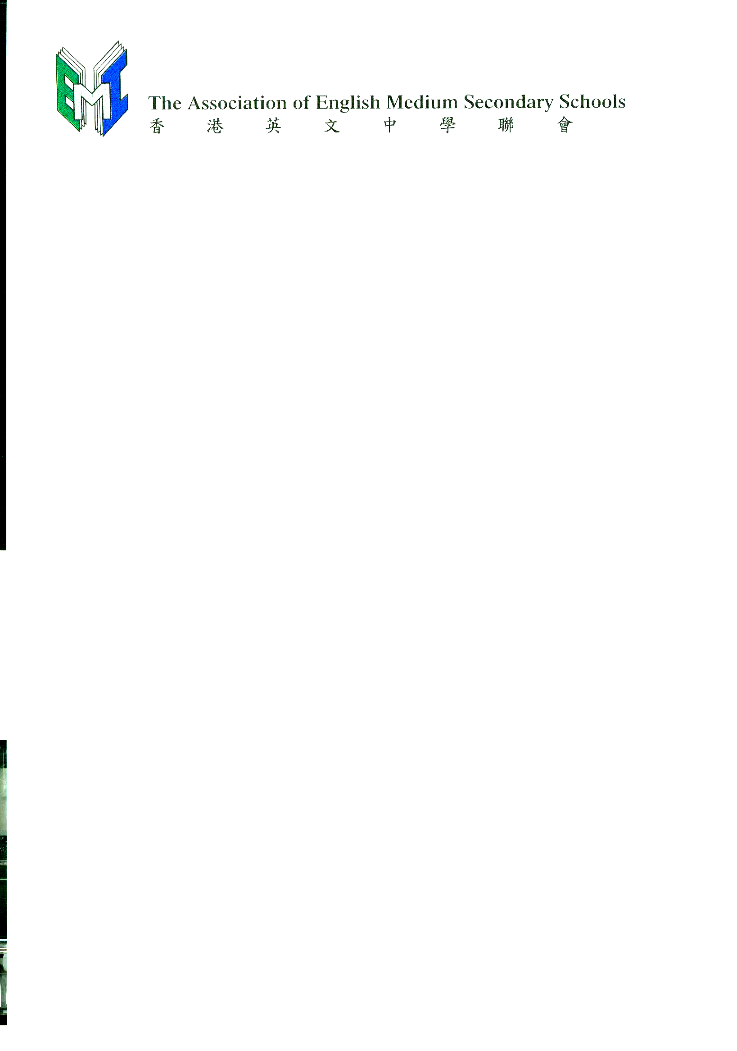
c/o YMCA of Hong Kong Christian College
2 Chung Yat Street, Tung Chung, N.T.

2 June 2008

Dear Principal / Art Teacher

Your Association is pleased to co-sponsor the Xu Bei Hong Arts Competition for Young Adults and Children（徐悲鴻盃青少年兒童美術比賽）with Xu Bei Hong School of Arts, Renmin University
of China（中國人民大學徐悲鴻藝術研究院）and their Hong Kong representative Hong Kong
Kam Sing Arts Association（香港金聲藝術協會）.

This is a prestigious competition and we encourage your students to participate in it. Selected works will be displayed at the Hong Kong Central Library, compiled and published. While students from all schools may take part in the Competition, only students from our member schools are eligible for the full scholarships that will enable them to visit Renmin University of China, Beijing.

Each school can submit a maximum of twenty original paintings to the following Collection Centres before Monday, 15 September 2008. (For the Collection Centre for your school, please refer to the fax sent you a few days ago.)

1. Shau Kei Wan Government Secondary School, 42 Chai Wan Road, Shaukeiwan, Hong Kong.
2. True Light Girls’ College, 54A Waterloo Road, Kowloon.
3. Kiangsu-Chekiang College (Shatin), Wo Che Estate, Shatin, N.T.
4. Tsuen Wan Government Secondary School, 70 Hoi Pa Street, Tsuen Wan, N.T.

Information pertaining to the Competition may also be found on the Association’s website a little later (www.emi.edu.hk).

Thank you.

Yours sincerely

Rosalind CHAN
Chairperson

Encl.: Posters promoting the Competition and twenty Application Forms.

